***CURTIN UNIVERSITY***

***SECURE DEVOPS – ISEC6000***

***ASSIGNMENT 1 – REPORT***

***Name – LOKU HELAPITIYAGE DON RANUL DEELAKA***

***ID – 21664678***

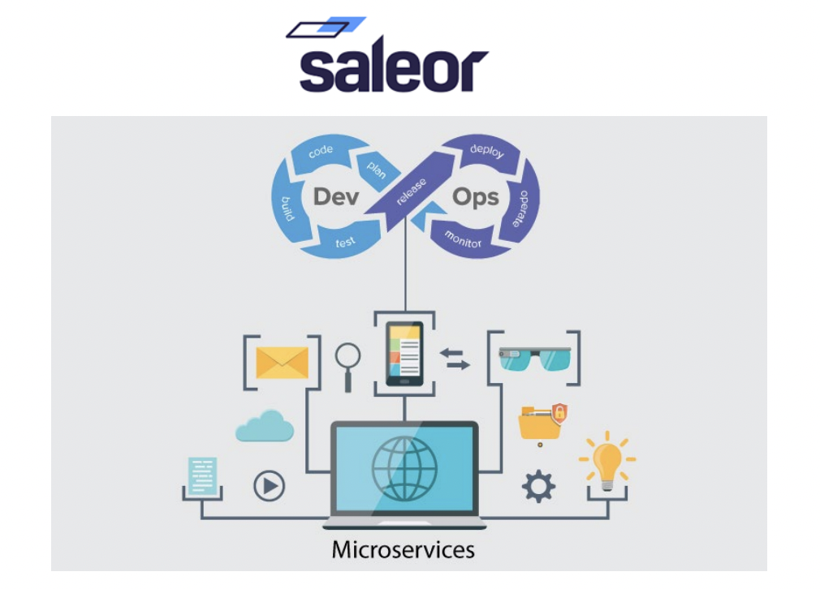

**TASK 01**

**Create a Kubernetes Cluster on GKE (or equivalent tool)**

1. Log in to your Google Cloud Console.

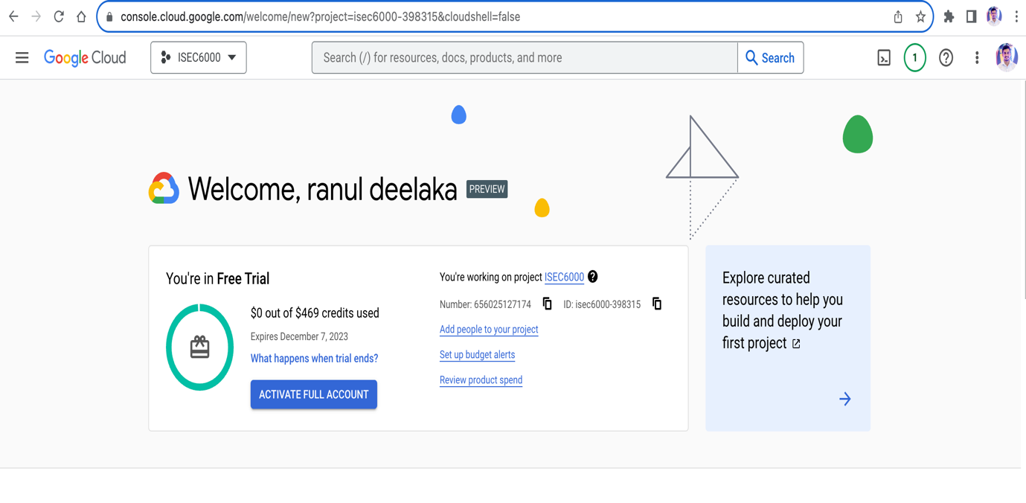

1. Navigate to the Kubernetes Engine section and click "Create Cluster."

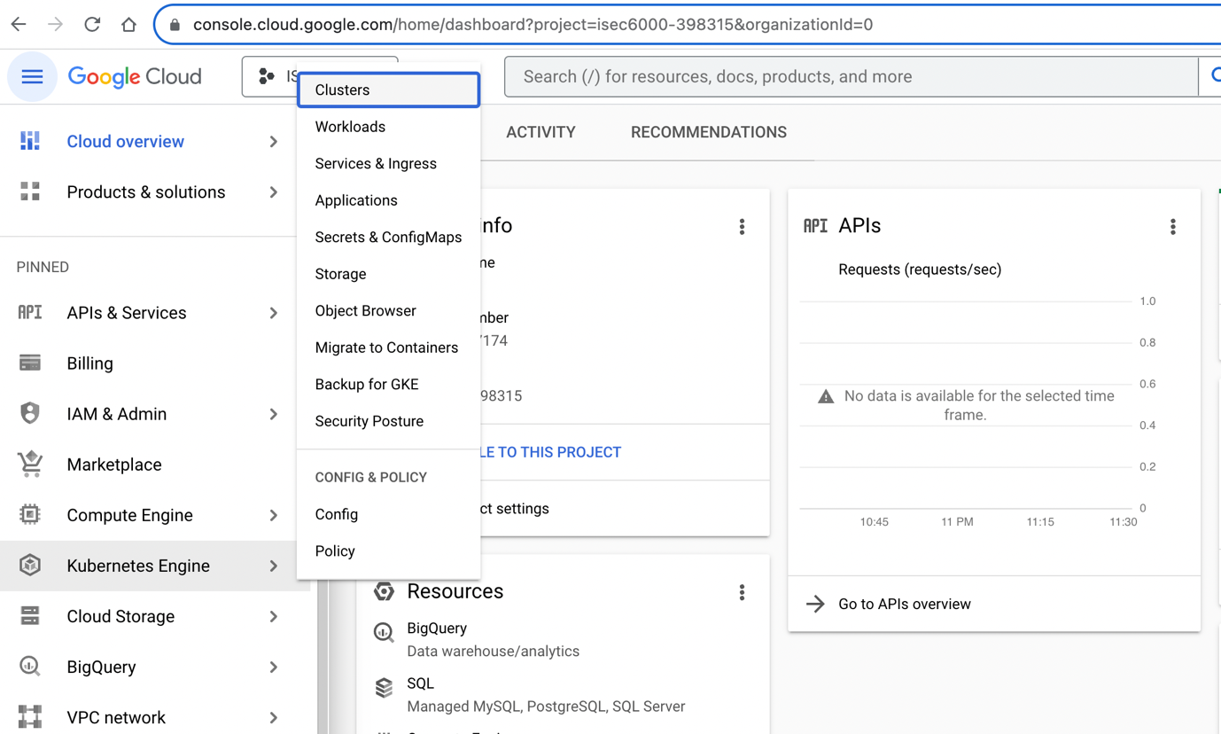

1. Configure your cluster settings, such as the cluster name, location, and node pool configuration.

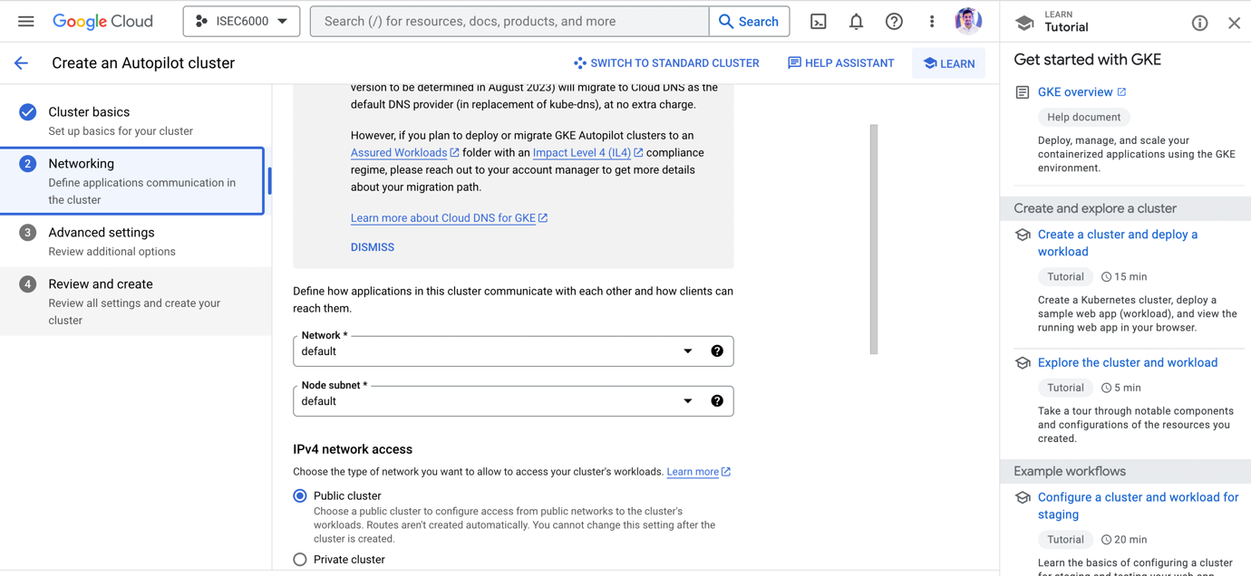

d. Choose the desired Kubernetes version.

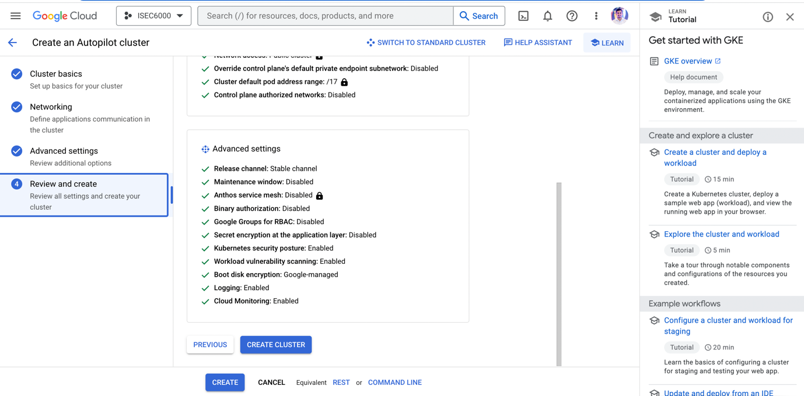

1. Click "Create" to provision your GKE cluster.

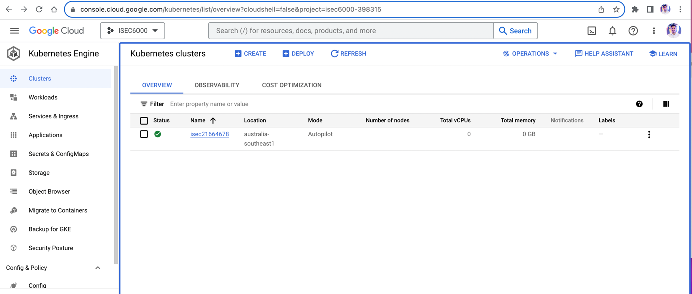

**Install and configure kubectl to manage your Kubernetes cluster.**

1. After creating the GKE cluster, you will need to configure your local environment to use kubectl to interact with this cluster.

To do this part I have used below commands.

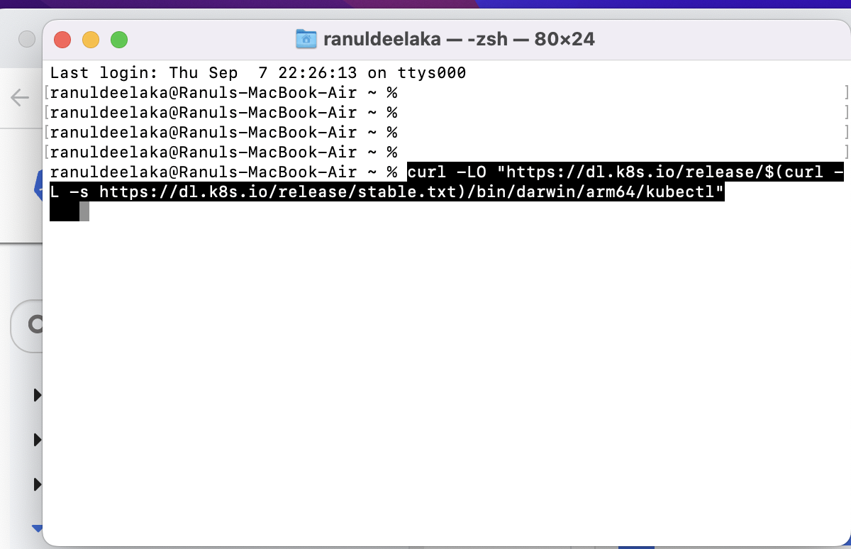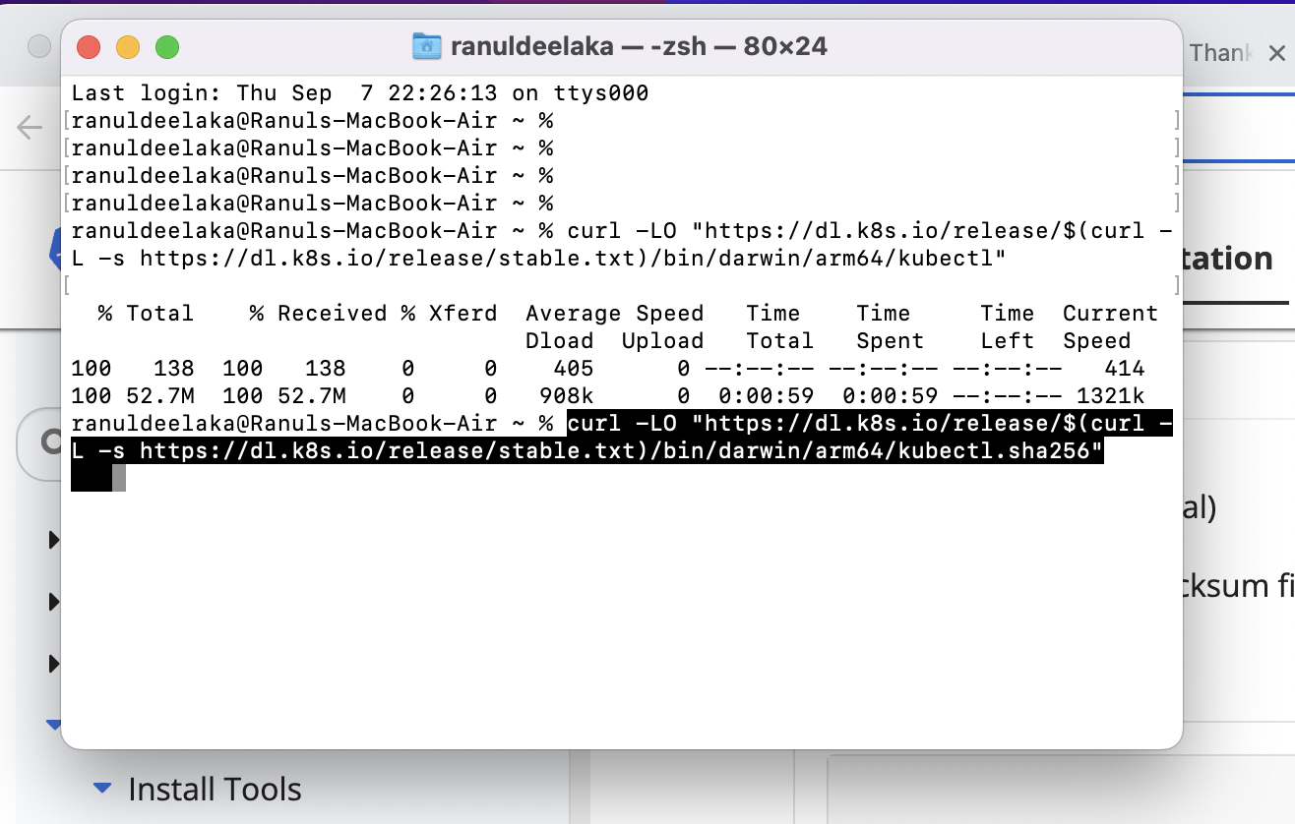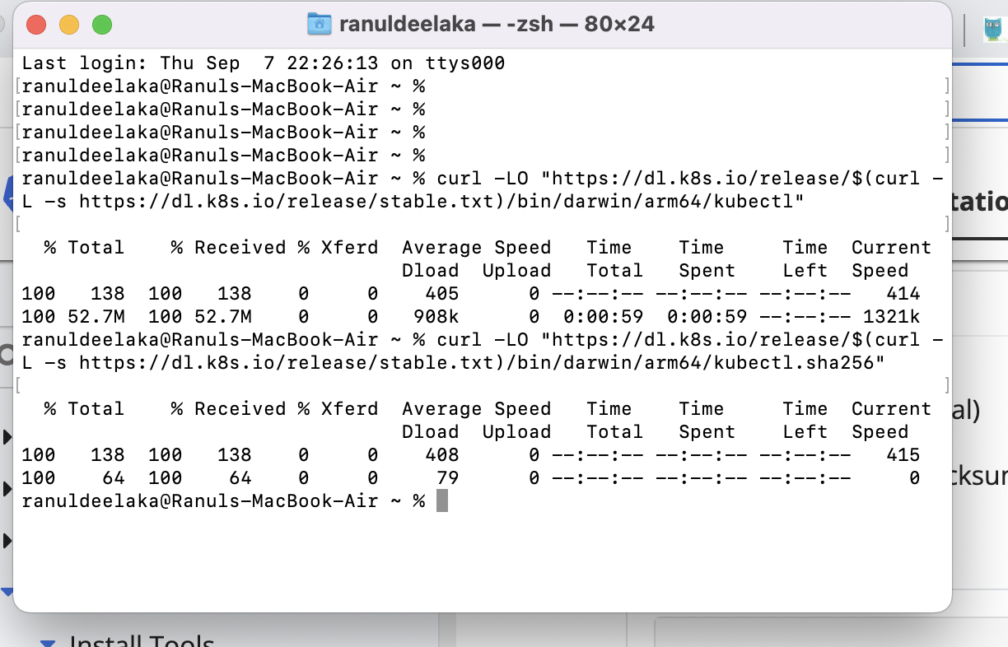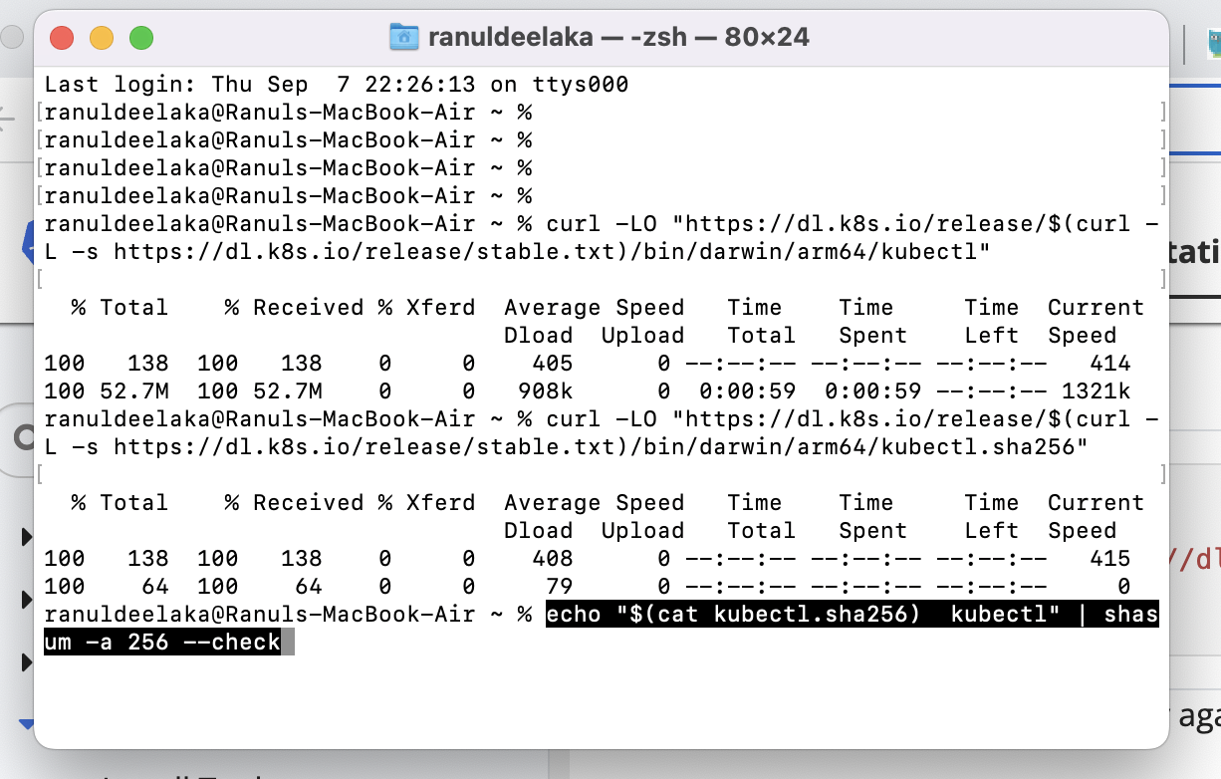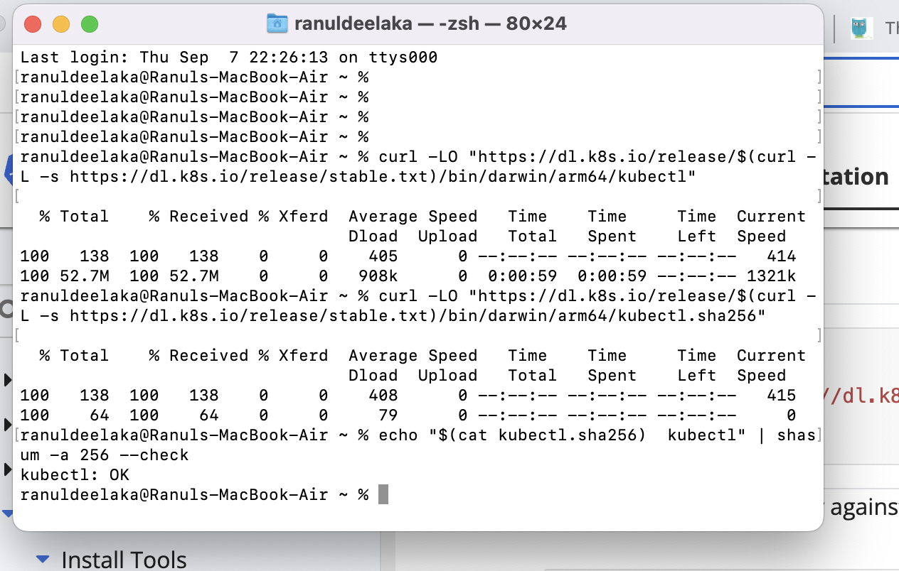

1. In the Google Cloud Console, navigate to the "Kubernetes Engine" > "Clusters" section and click the "Connect" button next to your cluster.

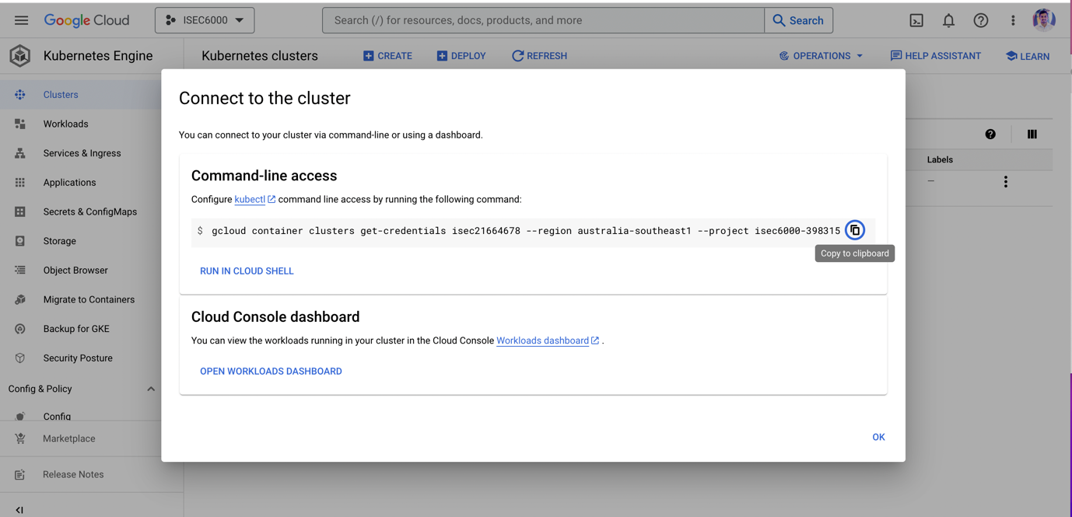

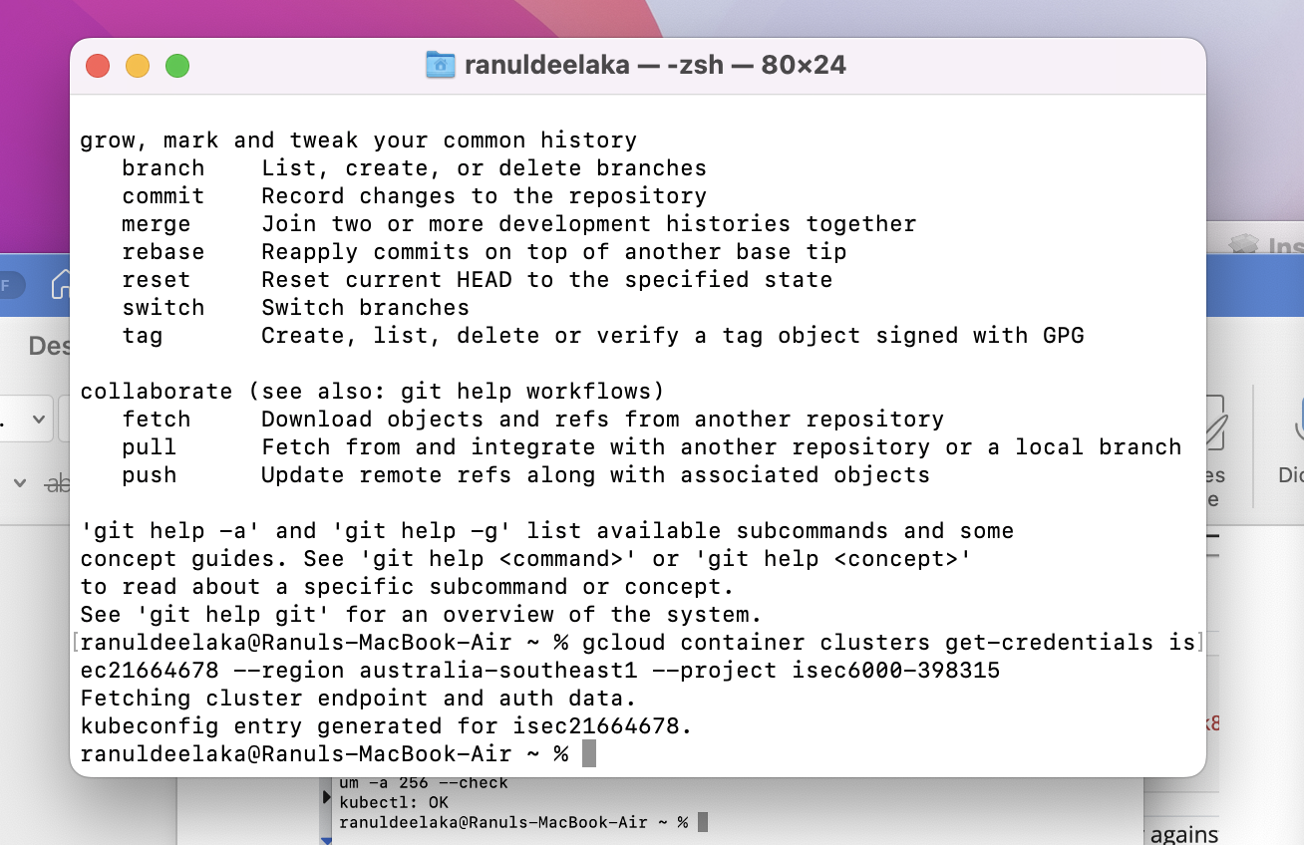

To configure upto this, I had an issue with the gcloud command not found. To fix this issue, I have followed below commands.

Step 1: Check if gcloud is Installed.

The first step is to check if gcloud is installed on your Mac. To do this, open a terminal window and type the following command:

gcloud version

Step 2: Add the gcloud Installation Directory to Your Path

If gcloud is installed but the installation directory is not in your PATH environment variable, you’ll need to add it. Here’s how:

1. Open a terminal window.
2. Type the following command to open your .bash_profile file:
3. nano ~/.bash_profile

(If you’re using a different shell, such as zsh, you may need to modify this command accordingly.)

1. Add the following line to the end of the file:
2. export PATH="$PATH:/Users/YOUR_USERNAME/google-cloud-sdk/bin"

Be sure to replace YOUR_USERNAME with your actual username.

1. Save the file by pressing Ctrl + X, then Y, then Enter.
2. Source your .bash_profile file by typing the following command:
3. source ~/.bash_profile
4. Verify that gcloud is now in your PATH by typing the following command:
5. echo $PATH

Step 4: Verify That gcloud Is Working

Finally, to verify that gcloud is working correctly, type the following command:

gcloud version

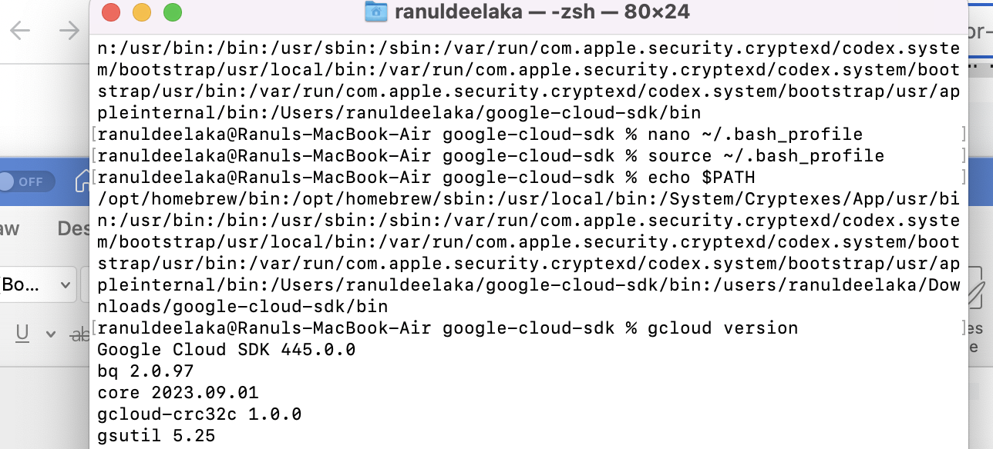

**When connect with the cluster, I had an issue with gcloud auth plugin as shown below.**

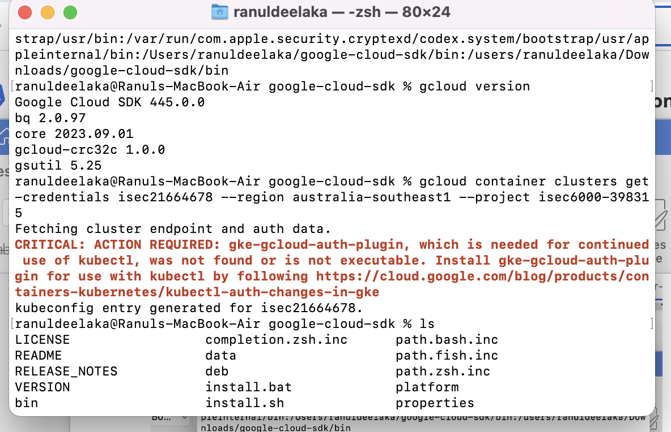

**To fix this issue, I used below commands to fix this issue.**

Run the following command:

gcloud components install gke-gcloud-auth-plugin

Run the following command:

sudo apt-get install google-cloud-sdk-gke-gcloud-auth-plugin

Run the following command:

sudo yum install google-cloud-sdk-gke-gcloud-auth-plugin

If this binary is installed correctly, the binary should be discoverable in the PATH. To verify that the installation worked correctly, open a new terminal and run

gke-gcloud-auth-plugin --version

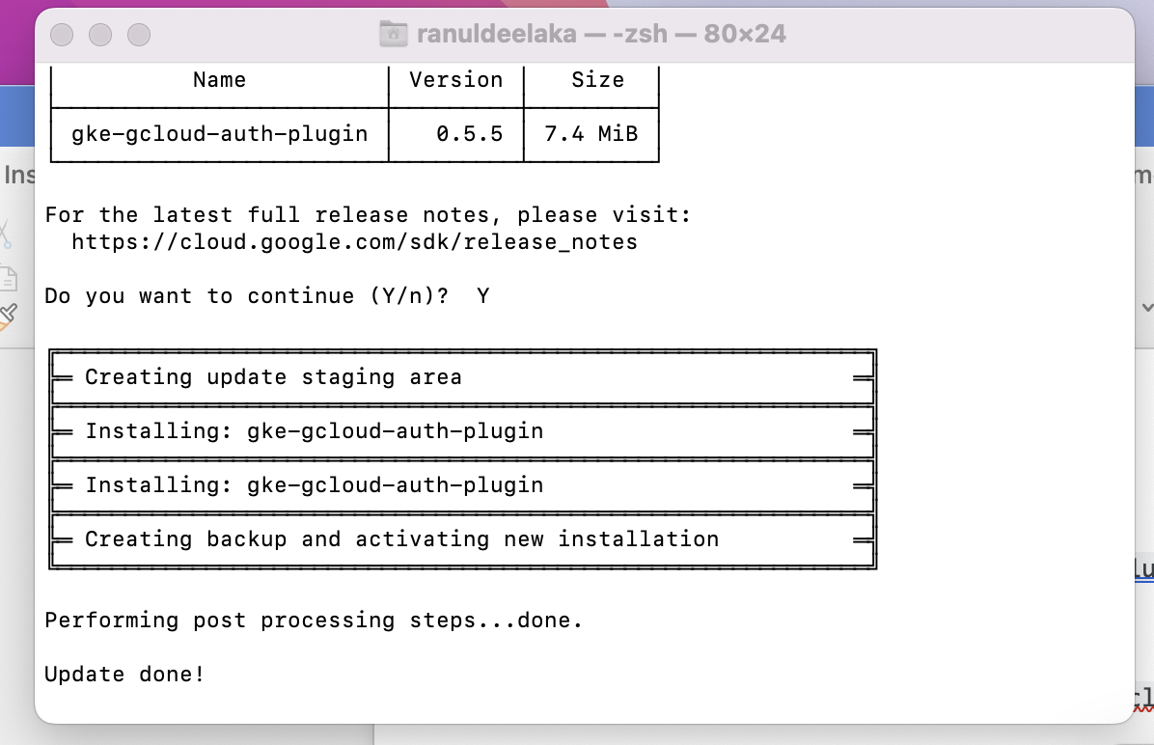

1. Follow the instructions to authenticate kubectl with your GKE cluster.

Run the script (from the root of the folder you extracted in the last step) using this command:

./google-cloud-sdk/install.sh

This can also be done non-interactively (for example, using a script) by providing preferences as flags. To describe the available flags, run:

./google-cloud-sdk/install.sh --help

To run the install script with screen reader mode on:

./google-cloud-sdk/install.sh --screen-reader=true

Open a new terminal so that the changes take effect.

To initialize the gcloud CLI, run [gcloud init](https://cloud.google.com/sdk/gcloud/reference/init):

./google-cloud-sdk/bin/gcloud init

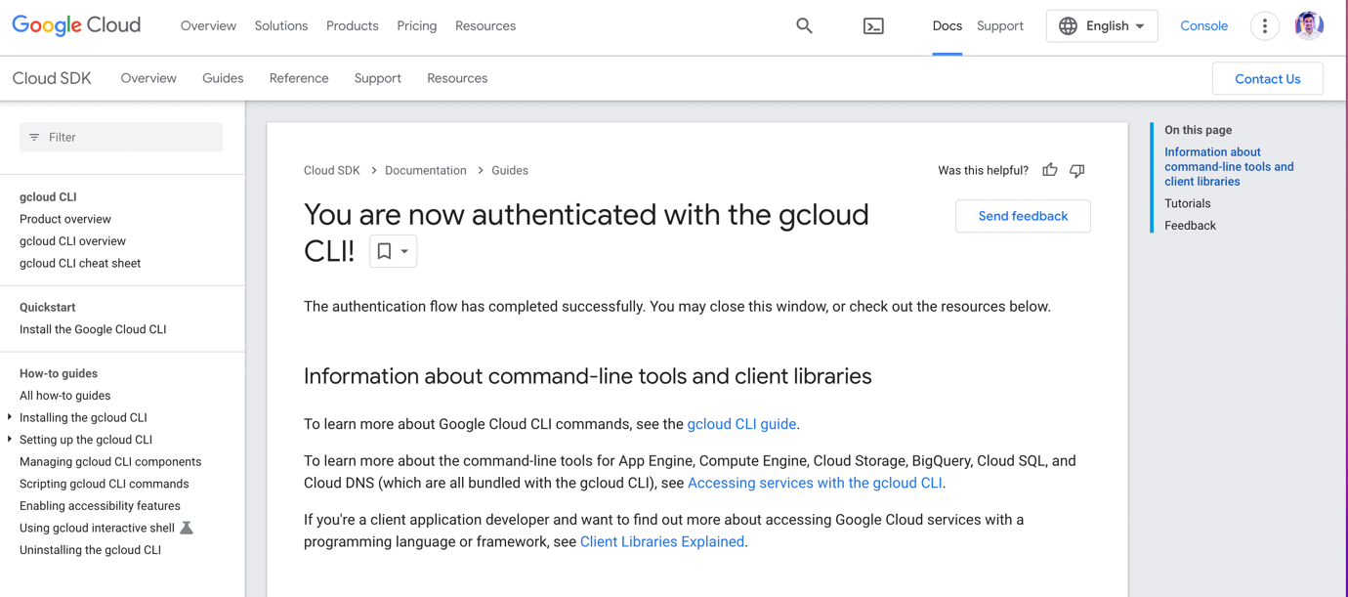

Set up a private GitHub repository to store your project files.

1. Log in to your GitHub account (or create one if you don't have it).

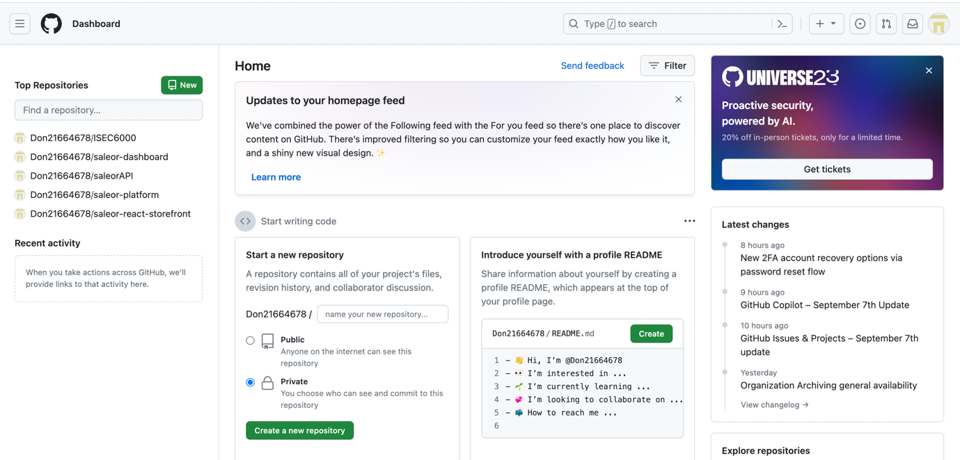

1. Click on the '+' icon at the top right corner of the GitHub dashboard and select "New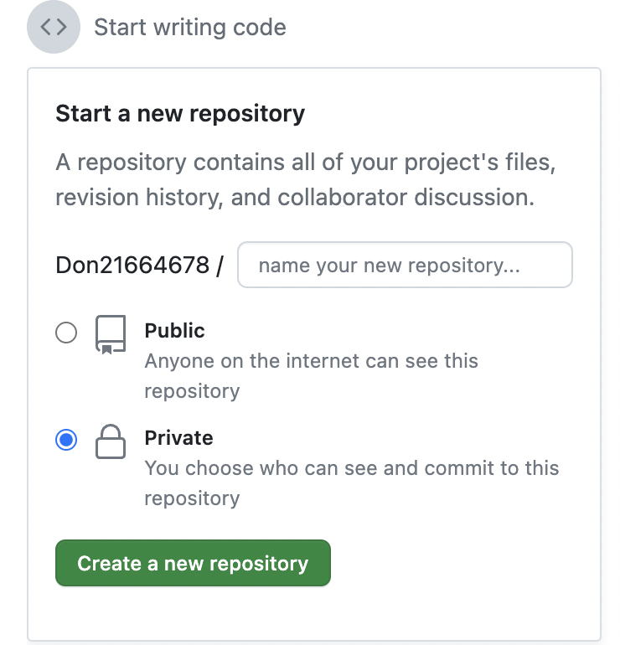
2. Choose a meaningful repository name for your ISEC6000 Secure DevOps project.

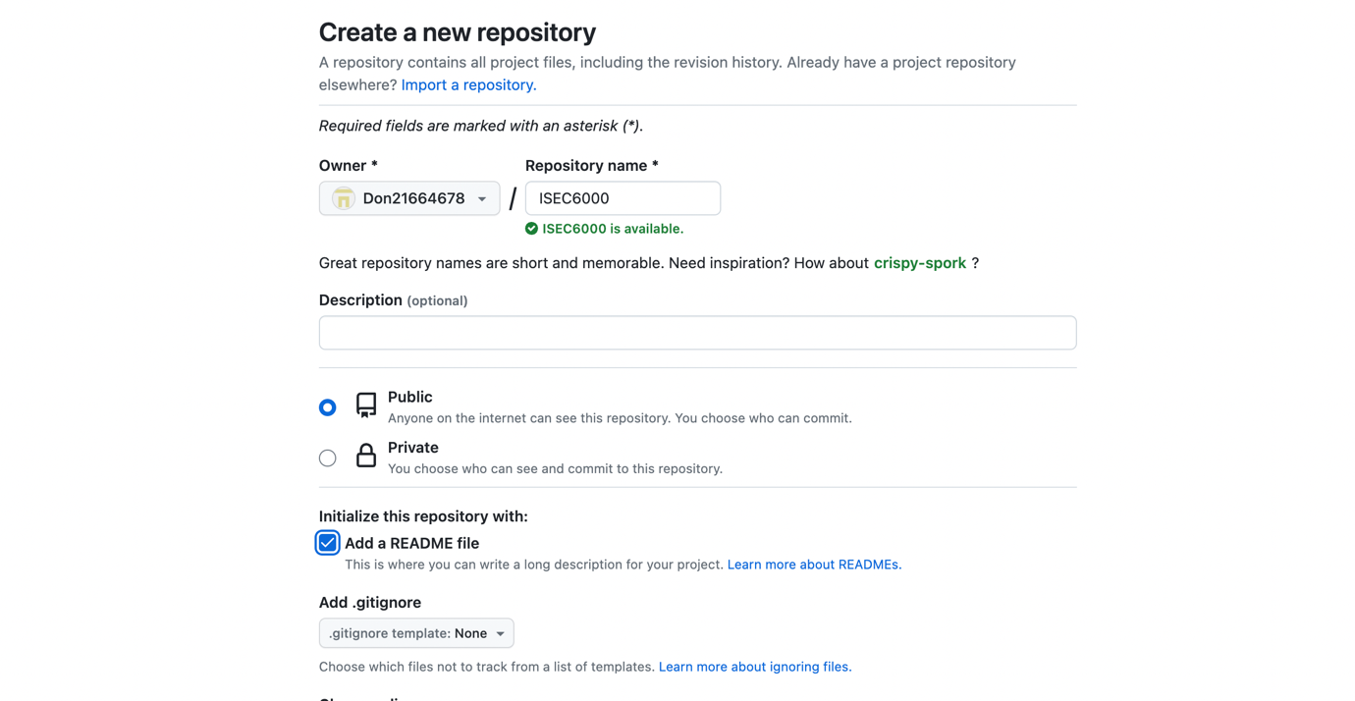

1. Select "Public" for the repository visibility. You need to add a description and choose whether to initialize the repository with a README. (Bonus marks if you have a proper README file. f. Click "Create repository."

